**CCT College Dublin**

**Assessment Cover Page**

|  |  |
| --- | --- |
| **Module Title:** | Time and Task Management |
| **Assessment Title:** | Formation of an IT Consultancy company |
| **Lecturer Name:** | James Garza |
| **Students Full Name:** | Kevin Esteff, Fernanda de Souza, Heloisa Eugenio |
| **Students Number:** | 2023286, 2023223, 2023264 |
| **Assessment Due Date:** | 22nd October 2023 |
| **Date of Submission:** | 22nd October 2023 |

**Declaration**

|  |
| --- |
| By submitting this assessment, I confirm that I have read the CCT policy on Academic Misconduct and understand the implications of submitting work that is not my own or does not appropriately reference material taken from a third party or other source. I declare it to be my own work and that all material from third parties has been appropriately referenced. I further confirm that this work has not previously been submitted for assessment by myself or someone else in CCT College Dublin or any other higher education institution. |

Table of Contents

Introduction 4

Description of the company 4

Main purpose introduction 4

Brief of the project 5

Main goal of the project & Milestones 5

Gantt Chart and Explanation 6

Developing process 7

Proof of brainstorming to decide the company purpose + selection of a project 7

Brainstorming 7

References 8

# **Introduction**

## 

## **Description of the company**

The company Stock track was created to Help a business in their day life into the company, and it operates in the field of the software technology, generally used for the hospitality environment. The primary focus is providing software solutions and tools to make the business in the hospitality sector accessible.

**Kevin** - Management, Planning process, and Gannt chart.

**Fernanda** - Research & Development, main purpose introduction, and analysing the final project.

**Heloisa** - Sales & Marketing, Development process.

## **Main purpose introduction**

The main purpose of the Stock track is to help businesses in the hospitality industry in efficient management in their inventory, purchasing, and cost control. Follow below the primary purpose of Stock Track.

**Inventory management**: stock track helps businesses to keep track all the inventory levels in the real time by integrating the stock track into other systems that company already use (like touchbistro and clover) so them they communicate between them and give the right stoke Sales, also allowed to monitor stock quantities, manager reorder points, and preventing overstocking and understocking of essential items.

**Cost control**: Stock Track assists a company in monitoring their sales, product cost identifying and reducing business expenses. By doing so, it enables companies to increase profit and maintain control over their profit margins.

**Purchase and order management**: Stock Track Streamlines purchase by establishing seamless communication with the supplier. This eliminates the need for manual order placement, allowing your management team to save time and effortlessly initiate orders directly through the application so who is managing the place don’t waste time to do the order and do it easier using the and ordering from there, also the app check and notify the manager with the missing items from the inventory so assists the management time.  
The app operates as a vigilant inventory, notifying the manager about the any low stock items. The system enhances proactive and positive management by ensuring if the essential item is always in stock.

**Recipe management**: Stock track is behind of the menus and pricing dealing with the cost management together with the inputs recipes making the company a part in what is going on with their company also all the staff to be able to perform the same recipe for each product like that ensuring all the company consistency in terms of stock, recipe product, and manager satisfaction.

**Vendor management**: Stock Track organize and maintain Database of their suppliers and track relevant information’s as collections of payment terms, historical data, and contacts (as the suppliers)

**Reporting and analytics**: Stock Track Offers the accountants from the business full logistic management of the inventory, order, and cost. The accountant or business owner has now a full website generated reports on inventory levels, purchasing historical, and financial performance. In this way this allow to the company members to be always aware of their company.

**Mobile accessibility**: Stock track also provide mobile app making accessible for everyone to use in their venue, allowing them to check the inventory Items, do the order, and manage cost. This app flexibility is very useful for the Stocktaking and management when they need to do an update.

**Planning process**

## **Brief of the project**

The Stock Track is a cloud-based platform that supports businesses of various sizes with procurement, stock delivery monitoring, and financial management. Its essential components encompass menu cloud Information, financial planning, supplier coordination and automated order recommendations.

## **Main goal of the project & Milestones**

Establishing company goals provides your team members something to work for and your corporation a direction. Without objectives, the organisation won’t have a clear sense of direction and may even be prevented from achieving the accomplishments it would otherwise have.

In the coming year, our business is committed to achieving several key goals and milestones. First and foremost, we aim to have an average customer base through targeted marketing and outreach initiatives, and in the coming months, focus on increasing the number of customers. Additionally, we will focus on enhancing our product line with the

introduction of two new innovative offerings, scheduled for release until the end of the year.

Lastly, we will prioritize operational efficiency by implementing cost-saving measures that aim to increase our profit margins by 15% over the next 12 months. There goals and milestones represent our dedication to growth, innovation, and financial sustainability as we continue to thrive in the competitive market.

# **Gantt Chart and Explanation**

We created a poll ourselves and decided what each person would work on, making it more comfortable to talk about the topics.

Within 20 days to have the 1st checkpoint done, we couldn’t have more than 5 days for each topic, or we would be late to upload the file, so we did well manage our time.

Our Gantt Chart contains all the group members, all their responsibilities with the timelines and deadlines until the 22nd of October, how everyone’s working on the project and it’s very easy to see and track.

# **Developing process**

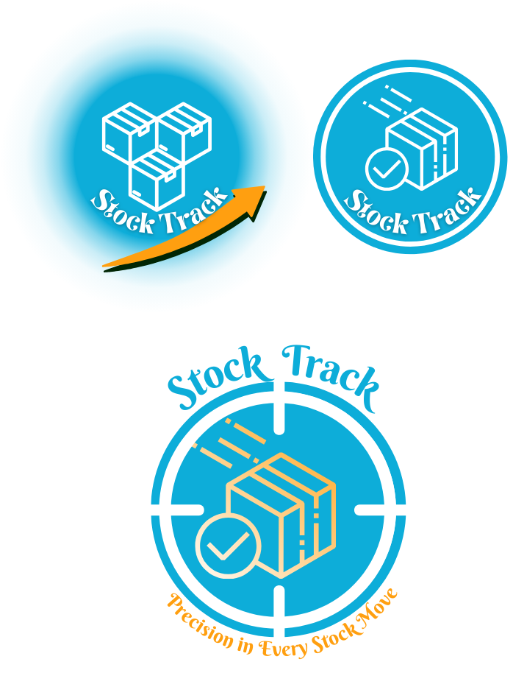

# **Brainstorming**

The company goal is the growth in the industry and reach a very good number of customers. We decided to bring new Stock control to the industry, related to the companies in general including restaurant, bar, hardware shops, etc.

The idea of this project is to work directly with company’s stock getting ideas with every person from the group.

Our manager department and the other departments sections were decided in a meeting after class.

# **References**

*10 company milestones to Aim For in your First year* (no date) *Online Bookkeeping Services for Small Businesses - Bench Accounting*. Available at: https://www.bench.co/blog/starting-a-business/company-milestones (Accessed: 12 October 2023).

MarketMan. (n.d.). *MarketMan: Restaurant Management Software (Free Demo)*. [online] Available at: https://www.marketman.com/.